

National University of Computer & Emerging Sciences, Karachi FAST School of Computing
Spring 2026 Lab Manual - 11
Course Code: CL-2005 | Course: Database Systems Lab
Instructor Name: | Ramsha Iqbal

Lab Tasks

Submission instructions: Perform the following tasks on Mongosh. Submit your query text along with screenshot of query + output.
- Create a database named SchoolDB.
- Create two collections:
  - Students
  - Courses
- Insert the following documents into the Students collection:
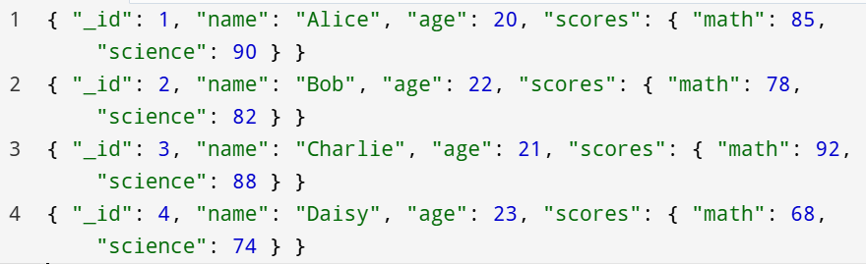
- Insert the following documents into the Courses collection:
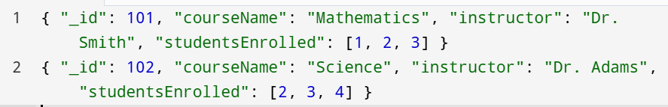
- Use findOne to retrieve:
  - A student where the math score is >= 85 and the age is < 22.
  - A course where the studentsEnrolled array includes 3 and the instructor is "Dr. Adams".
- Use find to retrieve:
  - Students with math score >= 80 and science score < 90.
  - Students whose age is < 23 or have a math score >= 85.
  - Students with science score >= 80 and (either math score < 75 or age > 22).

- Use updateOne to:
  - Increase the science score of the student where name is "Bob" and math score is >= 75.
- Use updateMany to:
  - Increase the math score by 5 for students whose science score is < 80 and age > 22.
- Use deleteOne to:
  - Remove a student where name is "Daisy" and their science score is < 80.
- Use deleteMany to:
  - Remove courses where the studentsEnrolled array includes 2 or the instructor is "Dr. Smith".
- Drop the Students collection.
- Drop the Courses collection.
- Finally, delete the SchoolDB database.

